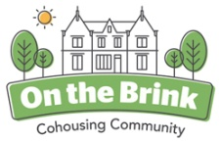Newsletter (mostly pictures to be fair) late October 2020

Here’s a picture to show off some of our new solar panels and a magnificent double rainbow seen from the top roof of Brincliffe House a few days ago.
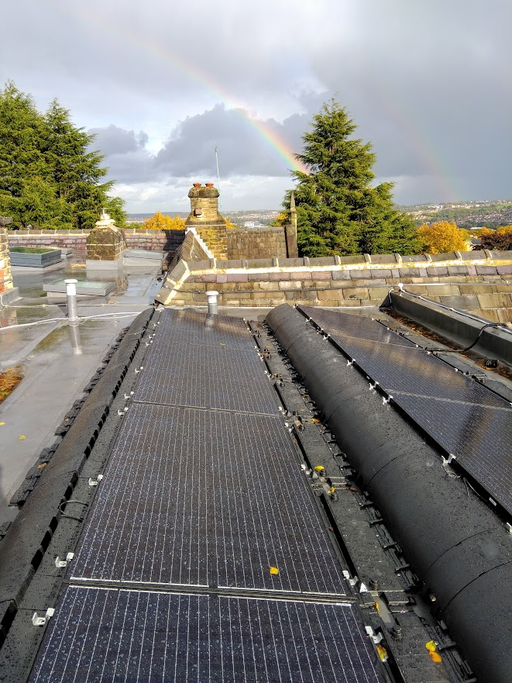
Meanwhile, at ground level our four new houses are getting very near completion. Of course there was a gap in the building work during the first Covid wave, but in general the work has being going on pretty much unaffected by all the turmoil around it.
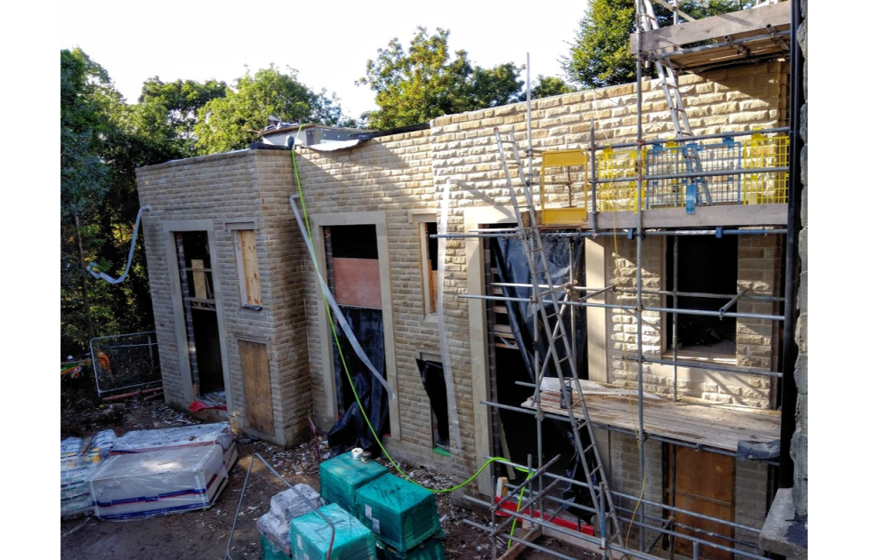
This group of photos shows the emerging three new townhouses.
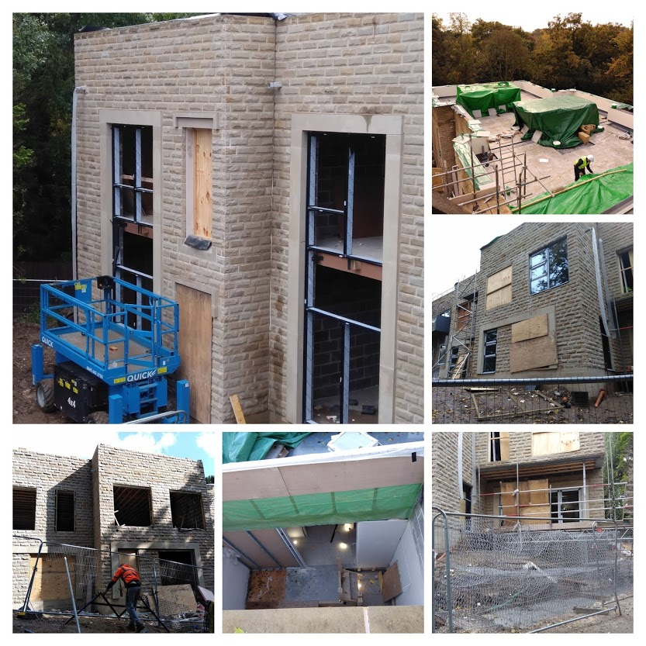

And here’s the wonderful new Lodge house (Brincliffe Lodge). Nearing completion now, closer than the three townhouses and looking as though it has always been there...
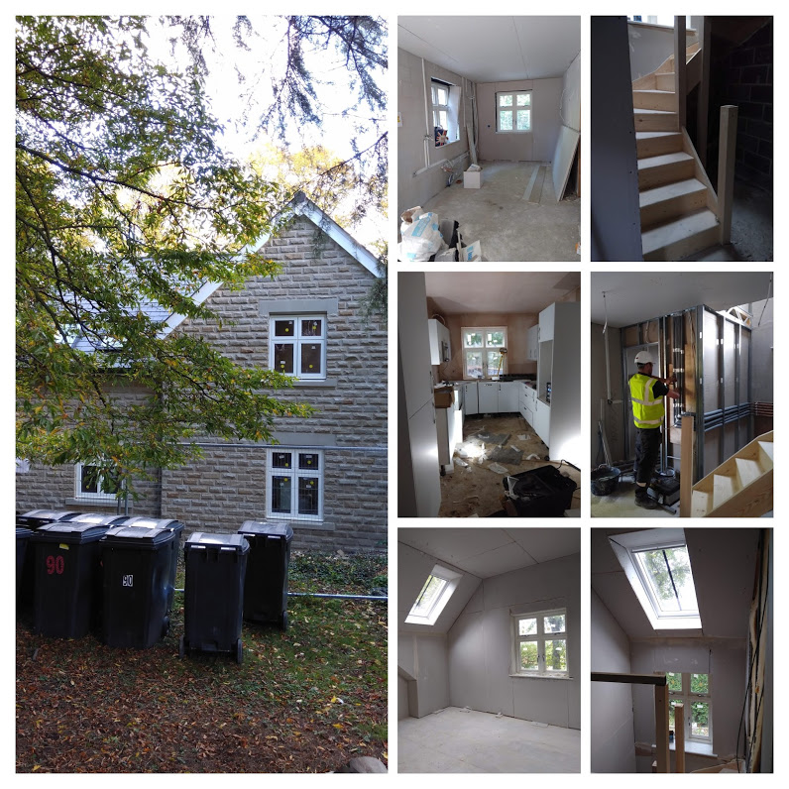
We’ve grown to love holes in the ground

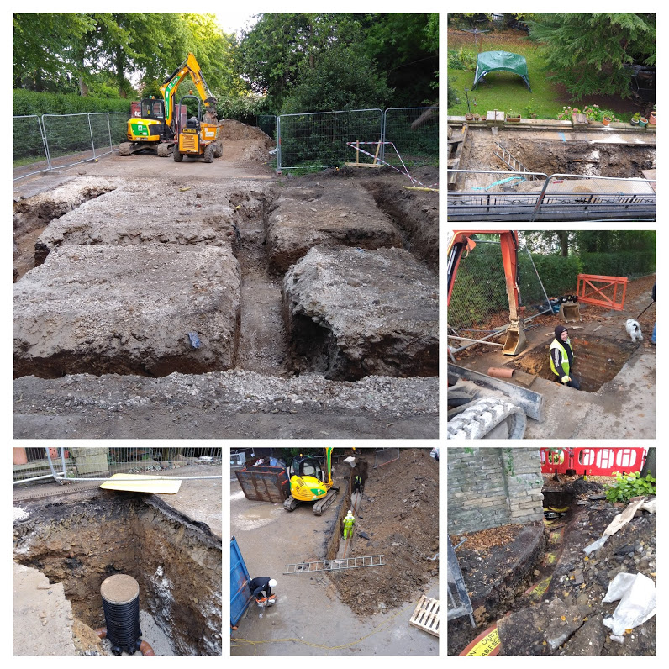
And we specially love watching the skill of the builders as they negotiate their massive vehicles around such a tight site.
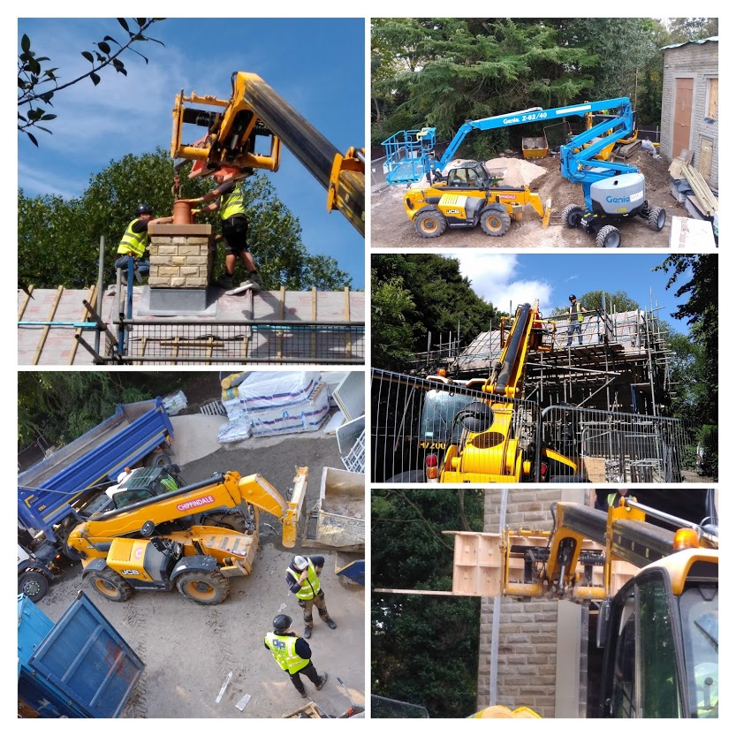
Apart from the thrill of watching the new buildings being assembled what else has been going on? Well - we have been trying to negotiate our way as an organisation that has as its purpose social cohesion through a global pandemic that can only be controlled through social distancing. Tricky isn’t it? It is true to say that we each have our own style of coping and are finding ways to make sure that the rather special Brinkie way of doing things is maintained as much as possible.
Newsflash: Our membership is now up to full strength (20 adults and six young people). We have been joined by Linda and Adrian who will be moving into flat 4 in the New Year - after all the building work is completed. It’s a fantastic scoop for On the Brink that they are joining us from Leeds. They have an impeccable background of decades of sustained community development work and their energy, skill and enthusiasm will be much welcomed here.
During various stages of lockdown and going through tiers of Covid control so far the weather has been kind and many meetings and activities have been held in the garden. There’s been regular dancing on the lawn or in the courtyard and meals and birthday celebrations etc. have been held al fresco. We’re doing our best to keep safe and cheerful.
We’ve now got a super gazebo in the courtyard to give an opportunity for some social interaction while keeping safe...
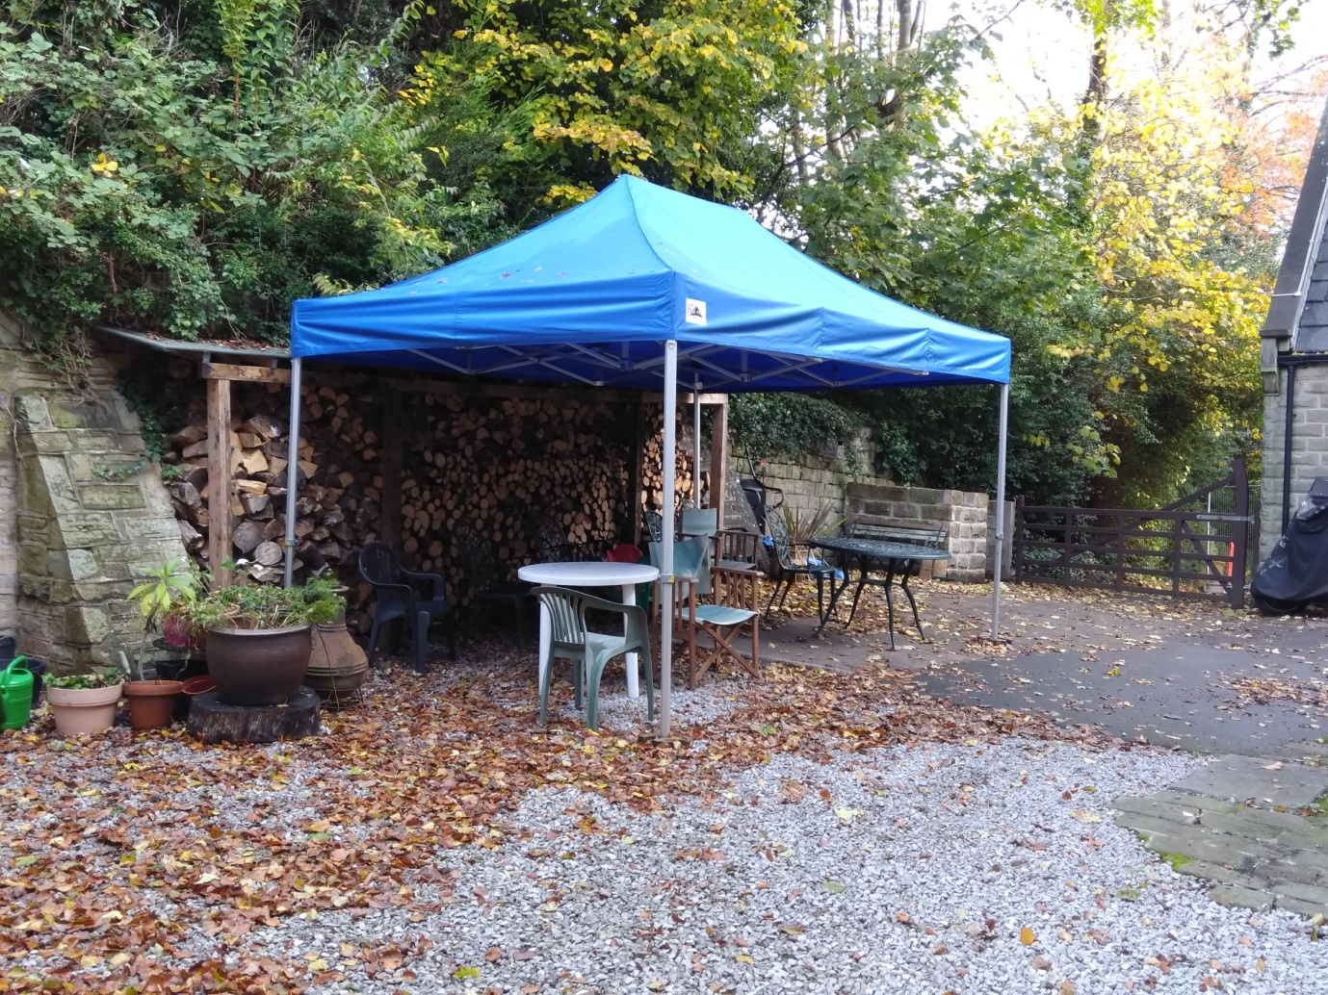
The young people on site are our beating heart. It’s such a treat to have each and every one of them contribute to our community in their special ways. If it takes a village to bring up a child then the opposite is certainly true. What sort of ‘village’ would this be without them? For the reasons that you will certainly respect we don’t take many photos of them or put their pictures in the newsletter or on social media... But they are very much here and we wish you could see them growing up and enriching our lives.

Hey – no newsletter without chicken photos. We are now down to three chickens but they are doing well although they never got the hang of the mechanical auto grain feeder thingy.
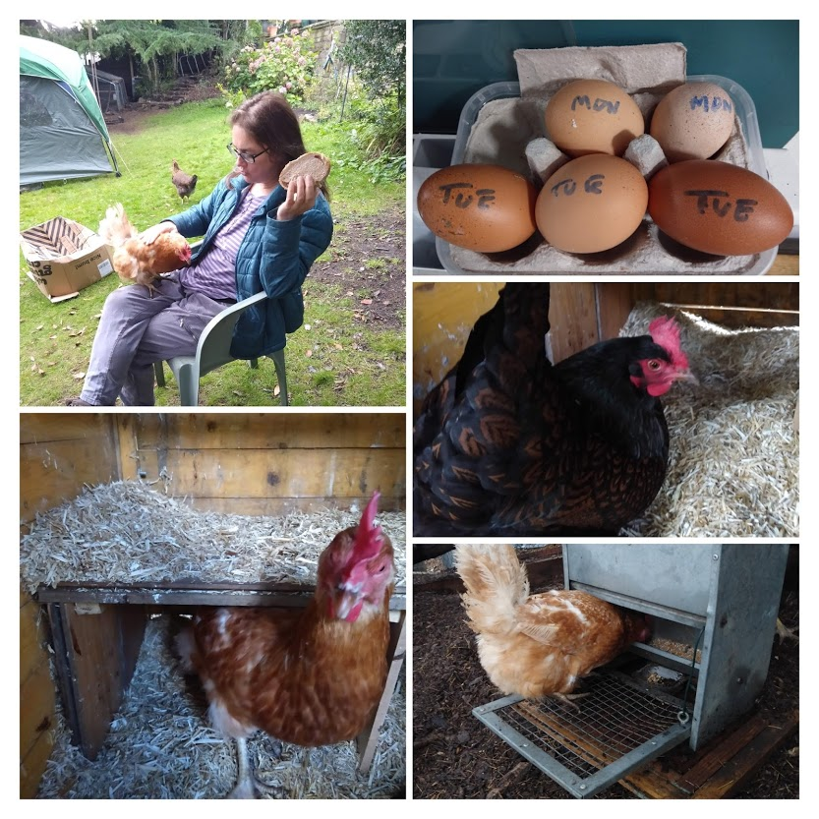
Have we shown you our super new Free Roadside Library?This has been positioned at the Brincliffe Crescent gate and seems to be great success. People actually take books from there and put in books for others to borrow...
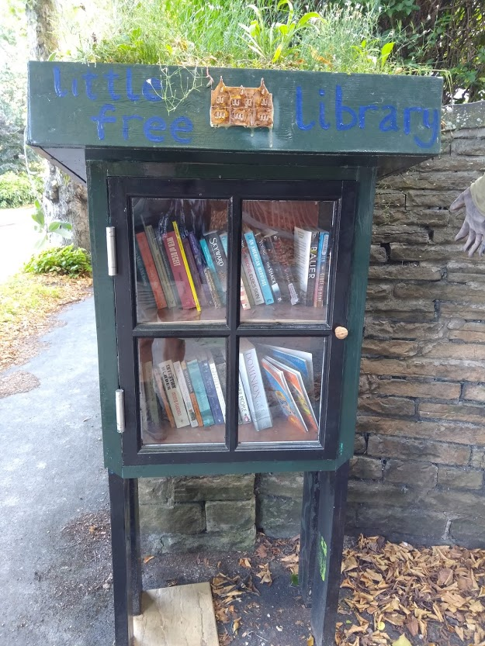
And to keep our spirits high we had a sunflower growing competition with lovely prizes for all. Here’s one of the entries...
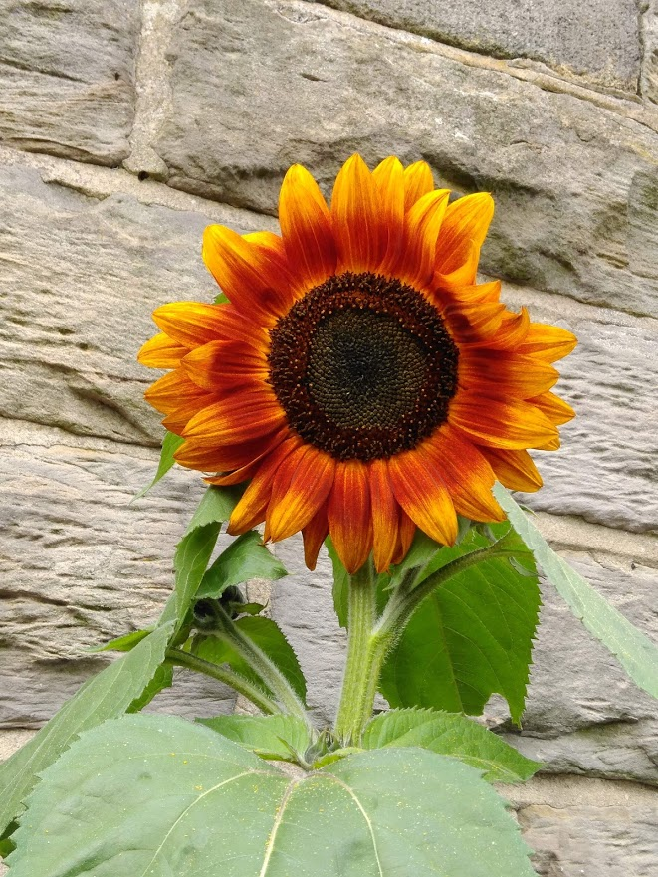
So we send greetings and thanks to all our friends and supporters in these uniquely difficult times.
Love to you all.

