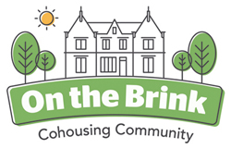

February Newsletter

Hello Dear Friends and Supporters,
One of the motivations for many of us doing this cohousing thing was to try to do something positive at a time when there’s so much negativity and disharmony in the world. The political world seems to have made individuals less and less able to actually change anything. Why not try to do something different and possibly creative?
Quite a high ideal - and obviously too early to reach any conclusions... but I will report some of the things we have been doing in our small way at On the Brink.
Right now we are awaiting the outcome of our latest planning application. We have applied to build four new, large living units in the grounds. The indications from the planners have been largely positive and the formal outcome of the planning application will be known in the next couple of weeks. As soon as the planning department have granted us permission it will be full steam ahead to put all the things in place that are needed to do the actual building work. There will be an opportunity for our friends and supporters to invest/ loan us the money we need to build the new houses and I will circulate details of that scheme as soon as we get planning permission.
Perhaps as diversionary activity, but as part of our grand plans for Brincliffe House we have been doing lots of work in the garden.

We have built a grand Bug Hotel
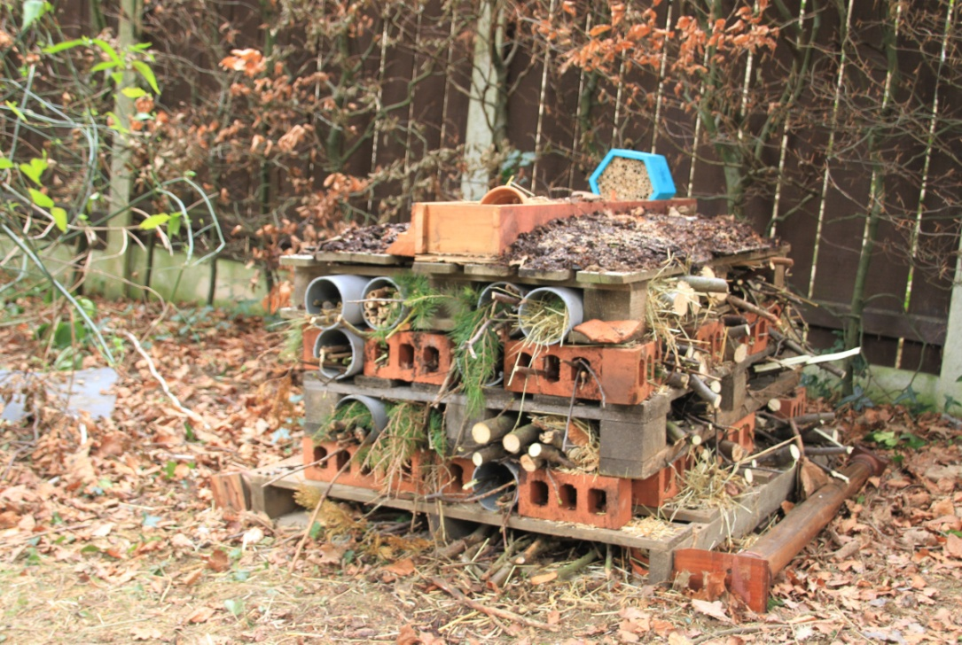
We have constructed and erected twenty (20) new bird nesting boxes.
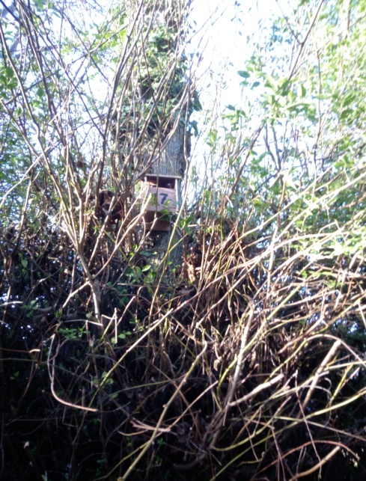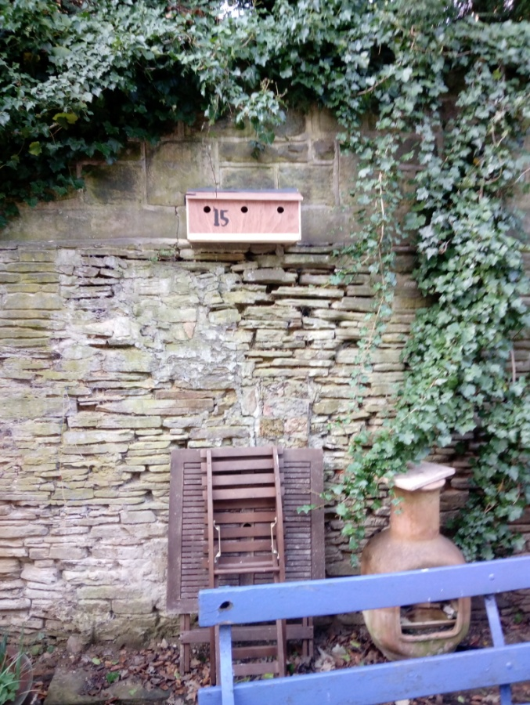

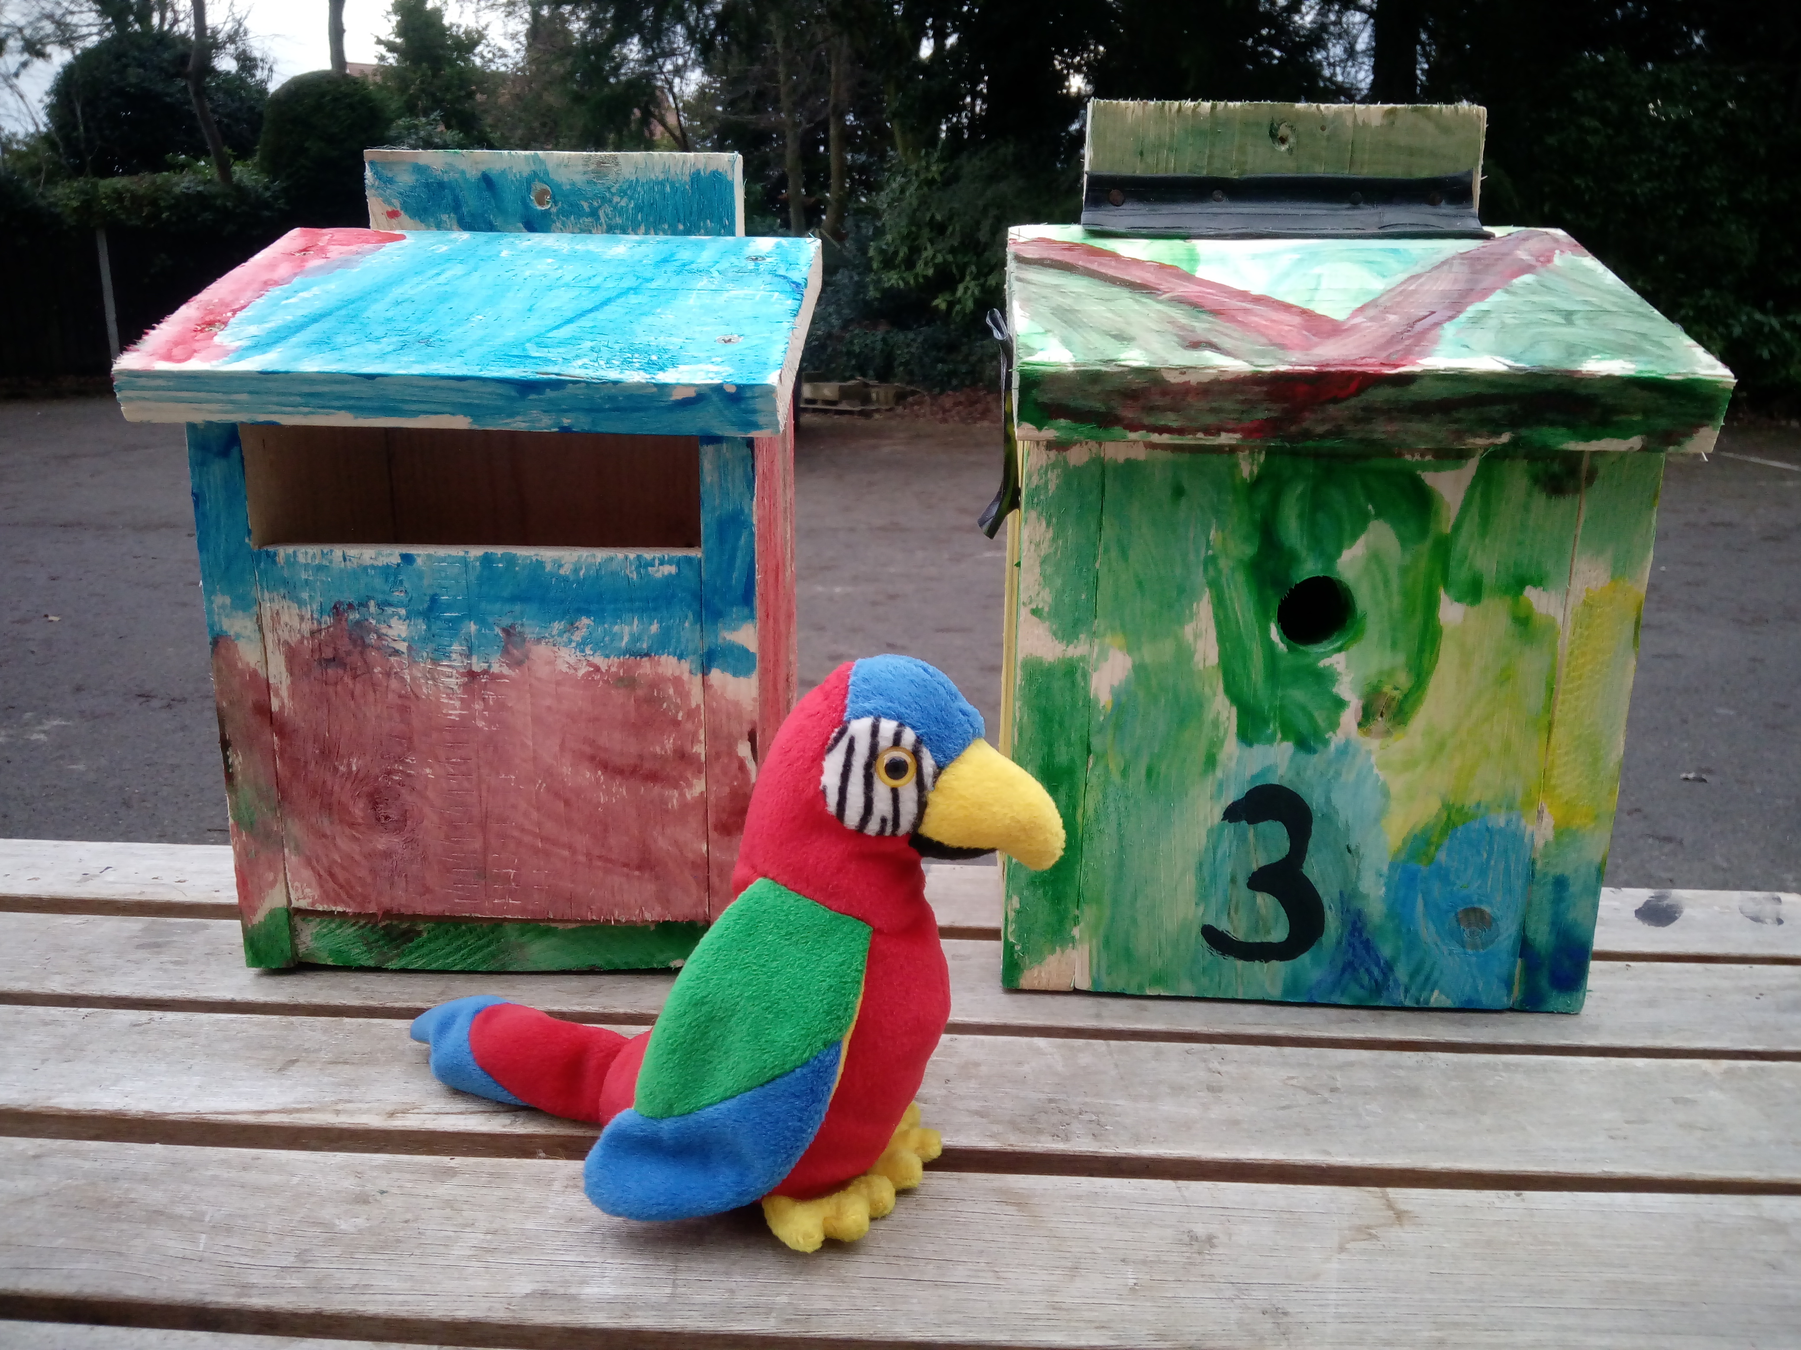
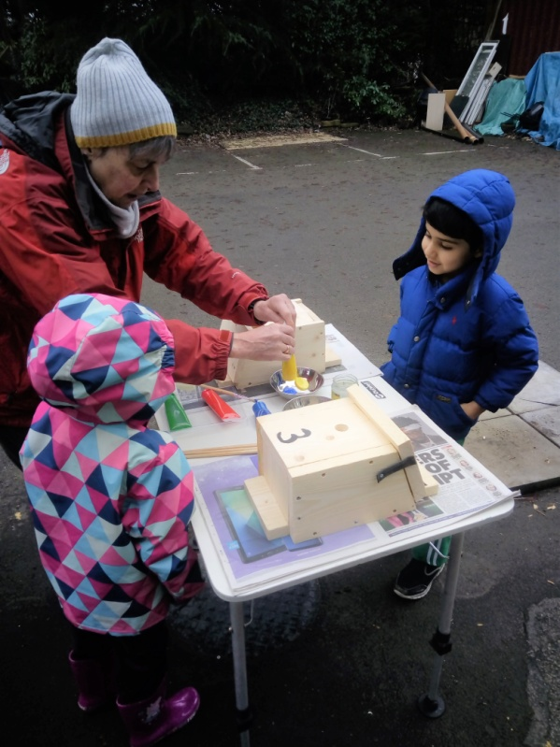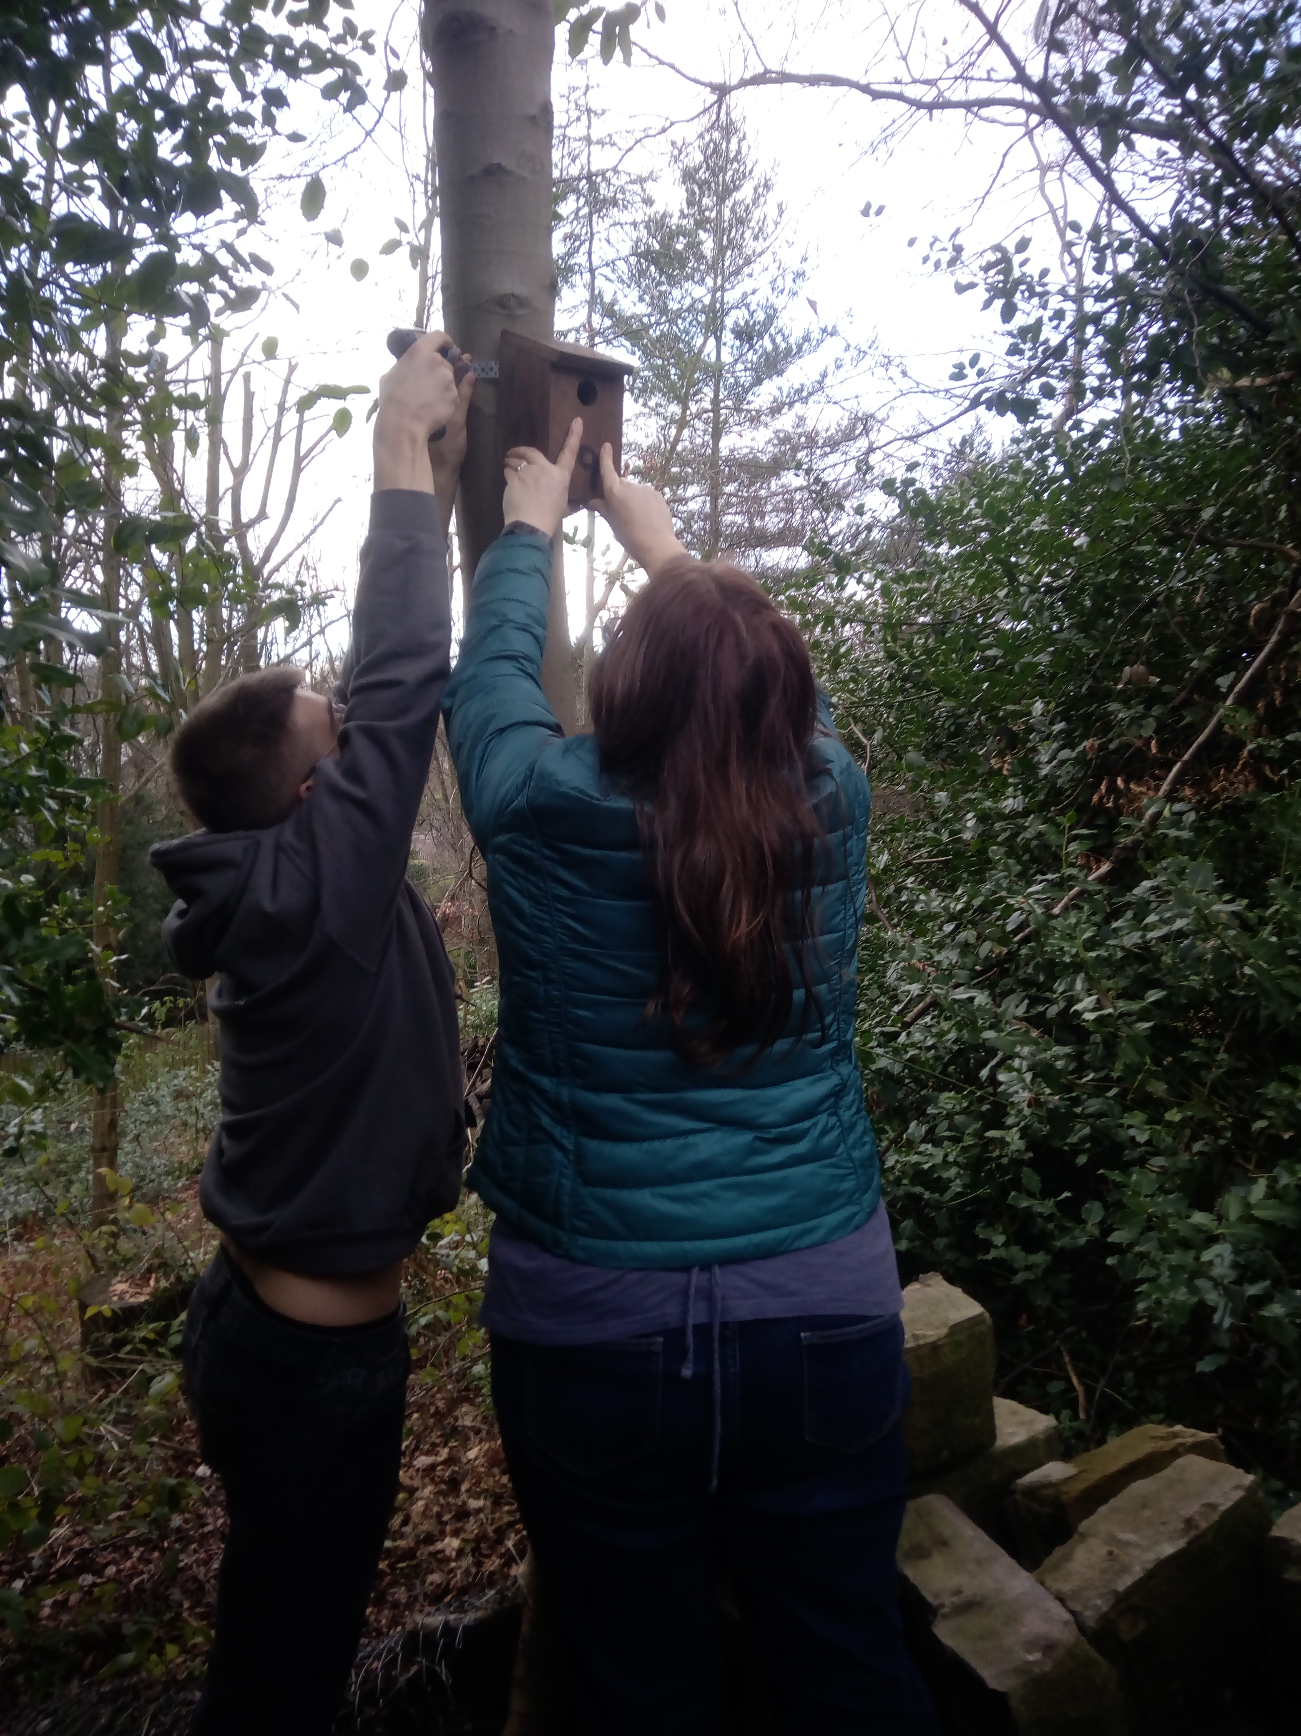
Including two owl boxes high in the cedar trees
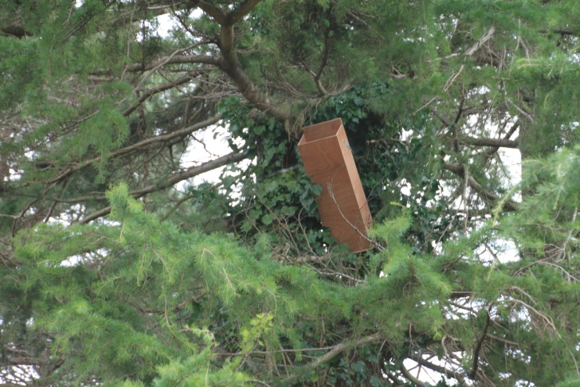
There’s a couple of bat boxes on the roof now.
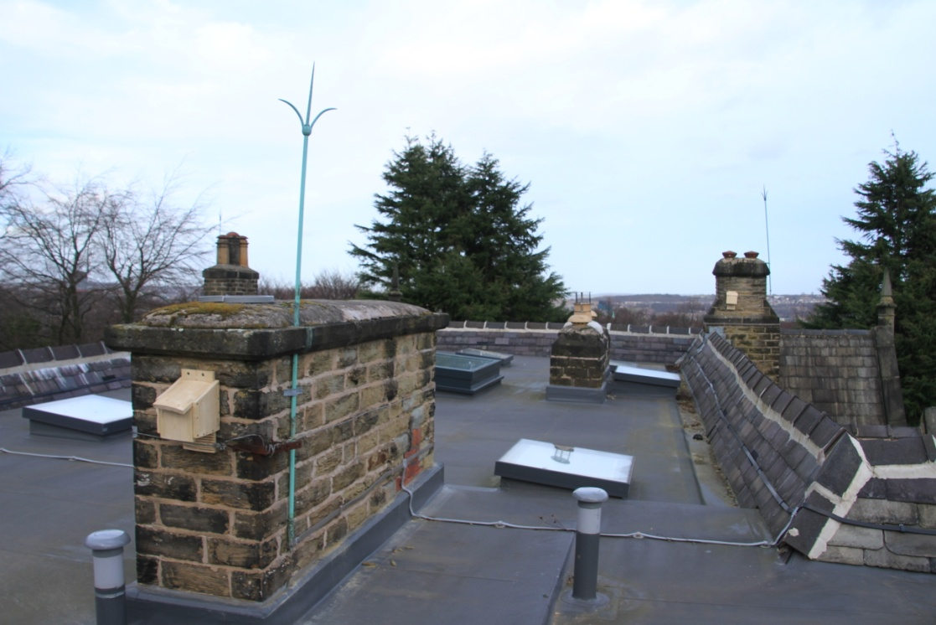
This is the view the bats will have from the roof...
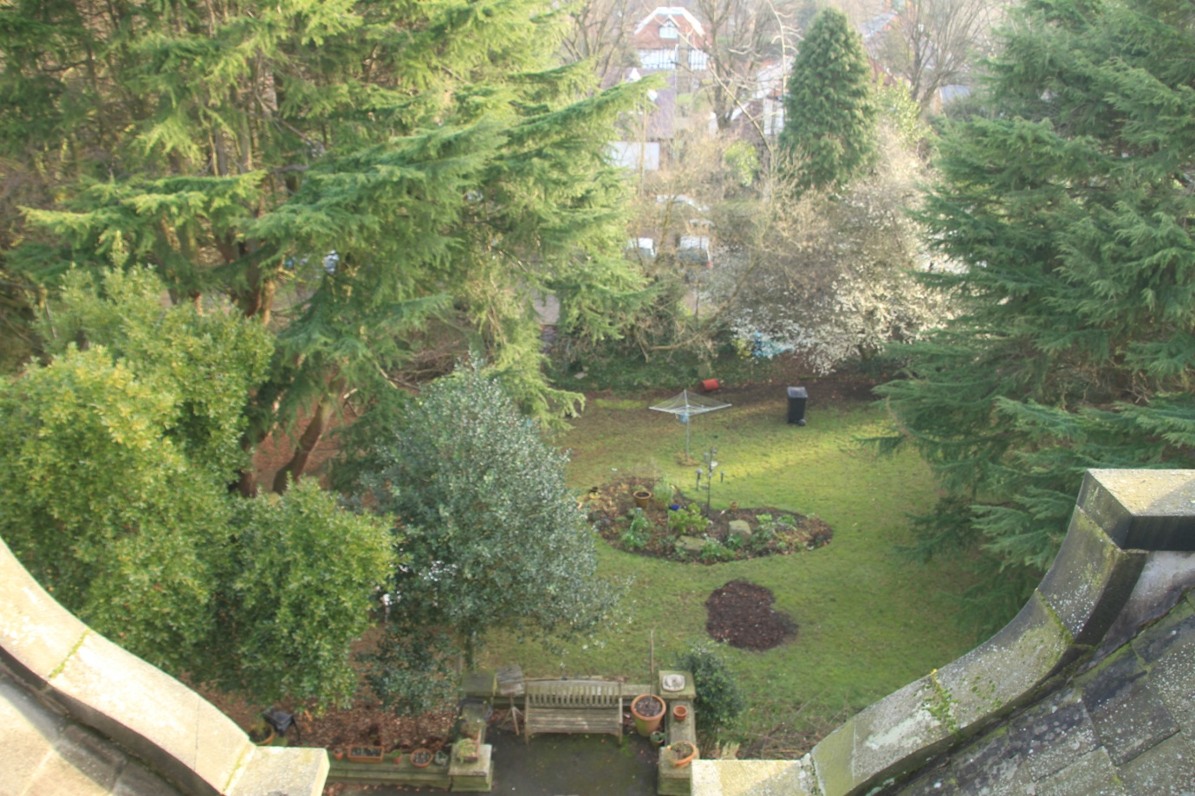

And in the back garden we are gradually taming the jungle and putting up a greenhouse that has been donated to us.
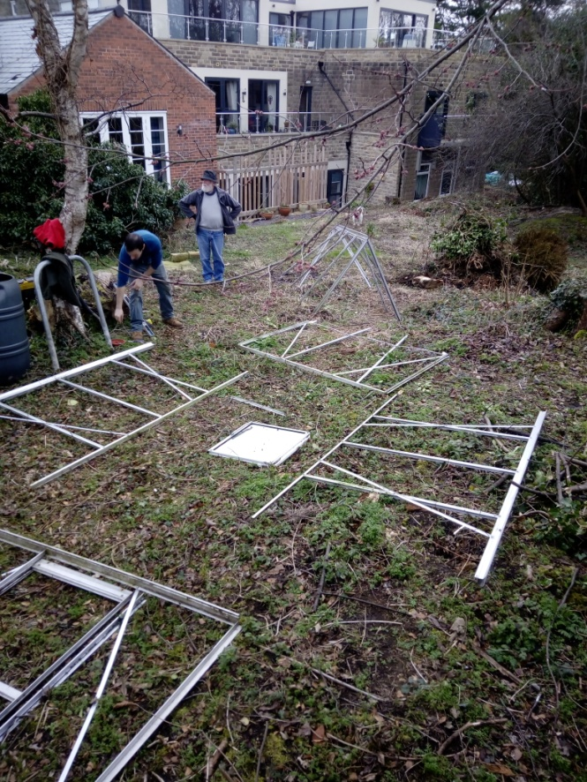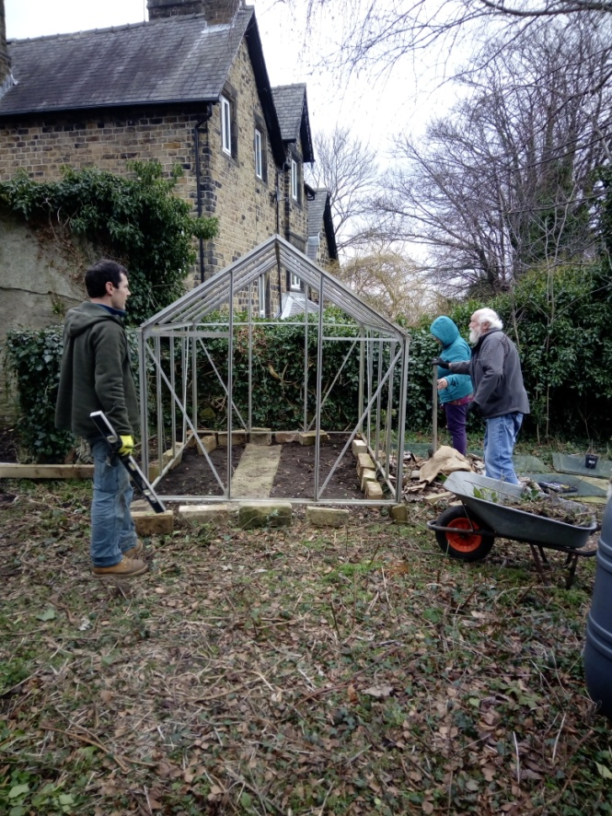
And if you thought that cohousing was all meetings and meetings about meetings let me immediately correct you. Here we live in a social whirl. There are regular sessions of yoga, Tai chi and our latest craze of Balkan dancing.
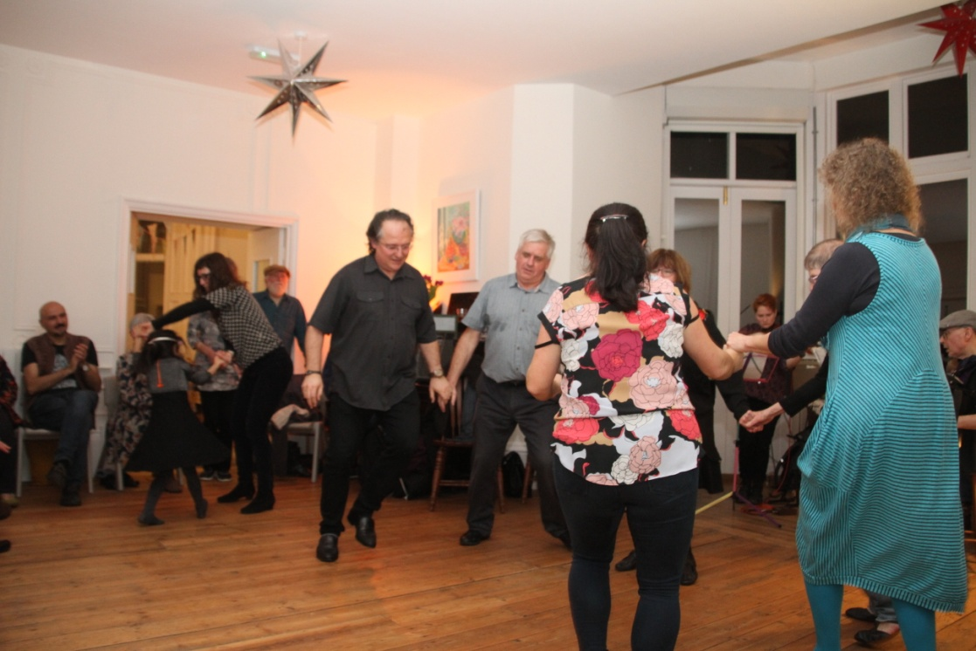
With twenty one OTB members now there’s going to be a birthday every 17.3 days on average. It seems that birthday parties last at least three days each so there’s precious little time to recover before the next one comes along.
Each Friday evening we have a shared meal together – sometimes with visitors as well. Everyone brings some food to contribute and the mix of delicious food is a delight every time.
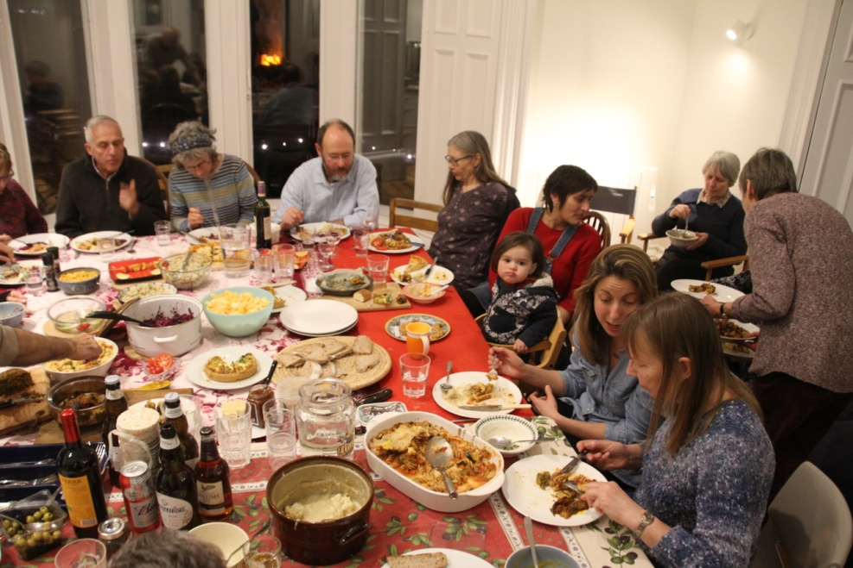
Perhaps this is the honeymoon period for our community, but it seems to heading in the right direction right now.
So that’s all for now. I will write again soon with a link to our new website and more details of our phase two building works and the external supporter loan/ investment scheme. Here’s the view from our terrace this morning.
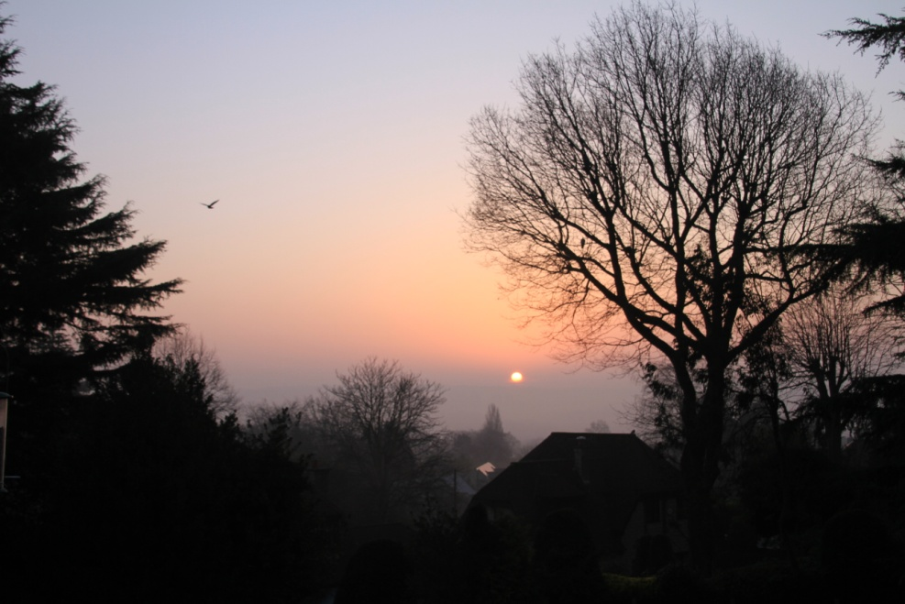
Love
Tom

